NAME ____________________

Exp/Log Review
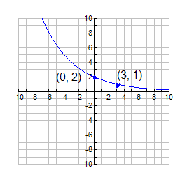
1) Determine the exponential function whose graph is shown in the figure.

Exercises 3 and 4: Graph the following:
3) 4)

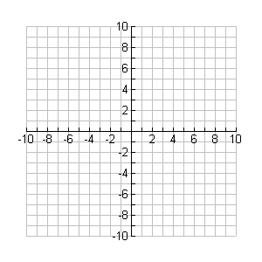

Exercises 5 and 6: Graph the following:

5) 6)

Exercises 7 – 10: Evaluate the logarithmic expression without using a calculator.

7) 8)

9) 10)

Exercises 11 – 12: Rewrite the equation in exponential form.

11) 12)

Exercises 13 - 23: Solve the equation.

13) 14)

15) 16)

17) 18)

19) 20)

21) 22)

23)
Applications:

24) Find the amount A accumulated after investing $450 for 3 years at an interest rate of 4.6% compounded annually.

25) Find the amount A accumulated after investing $4800 for 17 years at an interest rate 6.2% compouned quarterly.

26) How long would it take for your investment to double if it is compounded continuously at 8.5% interest rate?

27) If Jane invests $1500 in a savings account with a 6% interest rate compounded monthly, how long will it take until Jane’s amount has a balance of $5200?

